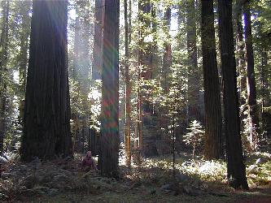
Jimmy experiences a lot of stress at work these days, especially since his accident made working diﬃcult. To relax after a hard day, he likes to walk home. To make things even nicer, his oﬃce is on one side of a forest, and his house is on the other. A nice walk through the for-est, seeing the birds and chipmunks is quite enjoyable.

The forest is beautiful, and Jimmy wants to take a diﬀerent route everyday. He also wants to get home before dark, so he al-ways takes a path to make progress towards his house. He considers taking a path from A to B to be progress if there exists a route from

B to his home that is shorter than any possible route from A. Calculate how many diﬀerent routes through the forest Jimmy might take.

Input

Input contains several test cases followed by a line containing ‘0’. Jimmy has numbered each intersection or joining of paths starting with 1. His oﬃce is numbered 1, and his house is numbered 2. The first line of each test case gives the number of intersections N, 1 < N ≤ 1000, and the number of paths M. The following M lines each contain a pair of intersections a b and an integer distance 1 ≤ d ≤ 1000000 indicating a path of length d between intersection a and a diﬀerent intersection b. Jimmy may walk a path any direction he chooses. There is at most one path between any pair of intersections.

Output

For each test case, output a single integer indicating the number of diﬀerent routes through the forest.

You may assume that this number does not exceed 2147483647.

Sample Input

- 6

1 3 2

1 4 2

3 4 3

1512

4234

- 2 24

7 8

1 3 1

1 4 1

3 7 1

7 4 1

7 5 1

6 7 1

- 2 1

6 2 1

0

Sample Output

2

4

